**SYNOPSIS**

The problem statement highlights the significant challenge of accurately predicting soil heat flux dynamics, which are crucial for regulating plant root zone temperature. Inadequate control of root zone temperature can lead to poor plant health, reduced crop yields, and increased vulnerability to pests and diseases, especially in the context of Indian agriculture, where productivity is often hampered by suboptimal soil temperature regulation.

The objective of this project is to develop a robust ensemble model using Temporal Convolutional Networks (TCNs) and Artificial Neural Networks (ANNs) to dynamically forecast soil heat flux. The model will leverage sequential environmental data and soil temperature records to predict heat flux, optimize root zone temperature, and ultimately enhance agricultural productivity.

The project involves two main tasks:

1. **Data Collection, Preparation**: Compiling dataset of soil temperature, other environmental factors and soil heat flux data.
2. **Model Development and Training**: Designing and training a Temporal Convolutional Network (TCN) that can capture complex temporal patterns in data and Artificial Neural Networks (ANN) to forecast soil heat flux with high accuracy.

By accomplishing these tasks, the project aims to improve agricultural productivity and sustainability by providing farmers with actionable insights into soil heat flux dynamics. This advancement aligns with India’s goals for food security and economic growth by reducing crop losses and optimizing farming practices through better soil temperature management.

**CHAPTER 1**

**INTRODUCTION**

In the evolving landscape of modern agriculture, ensuring the optimal health and productivity of crops is a critical challenge, particularly in regions like India where agriculture is significant for the economy. One of the key factors affecting crop health and yields is the regulation of soil temperature, particularly in the root zone. Fluctuations in soil heat flux, which govern the transfer of energy within the soil, directly impact the root zone temperature, influencing plant growth, resilience, and overall agricultural productivity.

Traditionally, managing soil heat flux dynamics has been a manual and labor-intensive process, often relying on observational methods and historical data to guide farming decisions. However, with increasing environmental variability and the growing demand for higher yields, traditional methods are becoming insufficient. Suboptimal root zone temperature management leads to reduced crop yields and increased vulnerability to diseases.

To address this challenge, this project seeks to leverage the power of ANN and TCNs to develop a predictive model capable of dynamically forecasting soil heat flux. By capturing complex temporal patterns in environmental data, the model aims to optimize root zone temperature, improve crop yields, and ultimately enhance the sustainability of Indian agriculture. This approach not only represents a breakthrough in soil heat flux prediction but also aligns with the goals of boosting agricultural productivity and ensuring food security.

## 1.1. PROBLEM STATEMENT:

* Productivity of Indian agriculture is often hampered by suboptimal soil temperature regulation, particularly in the root zone of plants.
* Inadequate root zone temperature control can lead to poor plant health, reduced crop yields and increased vulnerability to pests and diseases.
* Soil heat flux governs the transfer of energy within the soil.
* Need for handling sequential data and capturing complex temporal patterns.
* By leveraging TCN and ANN , this project aims to develop a forecasting model that can dynamically forecast soil heat flux and optimize root zone temperature.
* This advancement is expected to significantly improve agricultural productivity and sustainability in India, aligning with the nation's goals for food security and economic growth.

# CHAPTER 2

# LITERATURE SURVEY

**INTRODUCTION:**

Recent advancements in soil science have led to innovative approaches for predicting soil properties and dynamics, utilizing machine learning, remote sensing, and statistical techniques. These studies enhance the accuracy of soil moisture, heat flux, and other critical parameters, facilitating improved agricultural management and environmental conservation.

**LITERATURE SURVEY:**

1. Bruno César Comini de Andrade et al. address inefficiencies in traditional soil heat flux models by employing an Artificial Neural Network (ANN) to enhance predictions across diverse land covers in South America. Utilizing data from 23 flux towers, their model achieves up to a 43% reduction in mean absolute error. This approach highlights the importance of land cover information in improving predictive accuracy and understanding soil-plant-atmosphere interactions. ***[1]***
2. Leugim Corteze Romio et al. presents a numerical model aimed at the estimation of soil thermal conductivity using field experimental data. The model addresses the need for accurate predictions of thermal conductivity, which is significant for various applications in agriculture and environmental science. By utilizing empirical data collected from field experiments, the authors aim to enhance the reliability of soil thermal conductivity estimates across different soil types. ***[2]***
3. James F. Cross and Darren T. Drewry explore the application of ensemble machine learning techniques to improve the estimation of soil heat flux. By integrating machine learning models, the authors aim to enhance predictive accuracy while ensuring interpretability of the results. The research addresses the challenges associated with traditional methods, which often lack transparency and reliability in estimating soil heat flux across varying environmental conditions. ***[3]***
4. Yujie Liu et al. investigate the effectiveness of Temporal Convolutional Networks (TCNs) for time series prediction in their study. Recognizing the limitations of traditional forecasting methods, the authors aim to leverage the capabilities of TCNs to capture temporal dependencies in data. By employing this advanced deep learning architecture, the research seeks to enhance prediction accuracy and address challenges associated with modeling complex time series data. ***[4]***
5. Rameshwar Garg et al. provide a comprehensive survey of machine learning algorithms for time series analysis and forecasting. The study emphasizes the significance of accurate forecasting in various fields and examines models such as ARIMA, Prophet, and Long Short-Term Memory (LSTM) networks. By exploring both traditional and hybrid approaches, the authors offer valuable insights into the latest advancements in time series prediction methodologies. ***[5]***
6. Ruixue Li et al. addresses the limitations of existing soil prediction models, which often struggle with inefficiency and inaccuracy. By leveraging near-infrared spectroscopy data, the Multi_CNN model aims to simultaneously predict multiple soil properties, thereby improving the overall predictive performance. ***[6]***
7. Anze Liang et al. investigates the variations of soil heat flux (G) in riparian woodlands and its correlation with net radiation. Using data from automated sensors, the study finds that G is influenced by LAI and SWC, aiming to enhance energy balance models for these ecosystems. ***[7]***
8. Toby A. Adjuik and Sarah C. Davis investigated machine learning models for predicting soil CO2 emissions using the GRACEnet database. It finds that random forest and gradient boosting algorithms outperform others, demonstrating ML's effectiveness as a cost-efficient alternative to traditional measurement methods. ***[8]***
9. [Zoren P. Mabunga](https://ieeexplore.ieee.org/author/37088382646) and Jennifer C. Dela Cruzpresents an optimized model utilizing Gaussian Process Regression (GPR) to predict soil moisture levels in smart agriculture. By leveraging GPR’s ability to provide probabilistic predictions and quantify uncertainty, the study aims to enhance soil moisture estimation, which is crucial for effective irrigation management and crop yield optimization. ***[9]***
10. Anze Liang et al. investigates the effects of raising root zone temperature (RZT) on the growth and metabolite production of hydroponically grown leaf lettuce. Conducted under controlled air temperatures, the research aims to understand how a slight increase in RZT can enhance plant productivity and nutrient uptake, ultimately contributing to better crop yields in plant factory systems. ***[10]***

| **S.NO** | **PAPER TITLE** | **AUTHORS AND PUBLISHER** | **SUMMARY** |
| --- | --- | --- | --- |
| 1 | Artificial Neural Network Model of Soil Heat Flux over Multiple Land Covers in South America | Bruno César Comini de Andrade, Olavo Correa Pedrollo, Anderson Ruhoff, Adriana Aparecida Moreira  **(MDPI)** | **Advantages:**   * Improved accuracy with reduced mean absolute error. * Incorporates diverse land cover data for better predictions.   **Disadvantages:**   * Computational complexity requiring significant resources. * Potential for overestimation in specific land covers.   **Algorithm Used:**   * Artificial Neural Network (ANN) |
|  | A Numerical Model to Estimate the Soil Thermal Conductivity Using Field Experimental Data | Leugim Corteze Romio, Débora Regina Roberti, Lidiane Buligon, Tamires Zimmer, and Gervásio Annes Degrazia **(MDPI)** | **Advantages:**   * Enhanced accuracy in estimating soil thermal conductivity using real field data. * Broad applicability across various soil types and conditions..   **Disadvantages:**   * Accuracy heavily reliant on the quality and quantity of field data. * Calibration may require extensive data collection and processing.   **Algorithm Used:**   * Numerical modeling approach integrating empirical data |
| 3 | Ensemble Machine Learning for Interpretable Soil Heat Flux Estimation | James F. Cross, Darren T. Drewry  **(Elsevier)** | **Advantages:**   * Enhanced predictive accuracy compared to single-model techniques. * Improved interpretability of factors influencing soil heat flux.   **Disadvantages:**   * More complex to implement and tune compared to simpler models. * Requires high-quality datasets for effective training.   **Algorithm Used:**   * Ensemble Machine Learning Techniques |
| 4 | Time Series Prediction Based on Temporal Convolutional Network | Yujie Liu, Hongbin Dong, Xingmei Wang, Shuang Han  (**IEEE)** | **Advantages:**   * High accuracy in capturing long-range dependencies in data. * Allows for parallel processing, reducing training time.   **Disadvantages:**   * Implementation can be complex and requires careful tuning. * Needs large datasets to avoid overfitting and ensure effective training.   **Algorithm Used:**   * Temporal Convolutional Networks (TCNs) |
| 5 | Machine Learning Algorithms for Time Series Analysis and Forecasting | Rameshwar Garg, Shriya Barpanda, Girish Rao Salanke N S, Ramya Shivamadegowda  (**Cornell Archives)** | **Advantages:**   * Comprehensive overview of various forecasting methods available today. * Exploration of hybrid models enhances potential forecasting accuracy.   **Disadvantages:**   * Advanced models can be complex to implement and require expertise. * Performance is heavily reliant on the quality and quantity of data available.   **Algorithm Used:**   * ARIMA, Prophet, LSTM, and hybrid models. |
| 6 | Simultaneous Prediction of Soil Properties Using Multi_CNN Model | Ruixue Li, Bo Yin, Yanping Cong and Zehua Du **(MPDI)** | **Advantages:**   * Predicts multiple soil properties simultaneously. * Combines one-dimensional and two-dimensional convolutions for better accuracy. * Effective across diverse datasets and soil types. * Faster processing with dual-stream architecture.  Disadvantages:  * Requires more computational resources and expertise. * Needs high-quality near-infrared spectroscopy data. * Higher complexity can lead to overfitting.  Algorithm Used: Dual-Stream CNN (Multi_CNN):   * One-Dimensional Convolutions for spectral data. * Two-Dimensional Convolutions for spatial analysis |
| 7 | Daily Dynamics of Soil Heat Flux and Its Relationship with Net Radiation in Different Urban Riparian Woodlands | Anze Liang, Changkun Xie, Jing Wang and Shengquan Che **(MPDI)** | **Advantages:**   * Examines the interplay between soil heat flux and net radiation across various urban riparian woodlands. * Aims to enhance energy balance models, contributing to better simulations for riparian ecosystems. * Employs SPSS for data analysis, utilizing linear and polynomial regression models for robust results.  Disadvantages:  * The relationship between soil properties and environmental factors can be intricate, requiring extensive data collection and analysis. * Results may be specific to the studied locations, limiting generalizability to other regions or woodland types.  Algorithm Used:  * Data Analysis Techniques: Linear and polynomial regression models |
| 8 | Machine Learning Approach to Simulate Soil CO2 Fluxes under Cropping Systems | Toby A. Adjuik and Sarah C. Davis  **(MDPI)** | **Advantages:**   * Demonstrates that ML can accurately predict soil CO2 fluxes using readily available field data. * Offers a more efficient alternative to traditional measurement methods for estimating soil CO2 emissions. * Leverages the extensive GRACEnet database, enhancing model training and validation.   **Disadvantages:**   * Some ML algorithms may require substantial computational resources and expertise for implementation. * The study identifies that certain variables, while influential, may not be highly predictive in correlation analysis.   **Algorithm Used:**   * KNN: K-nearest neighbor regression. * SVR: Support vector regression. * RF: Random forest regression. * GB: Gradient boosted regression. |
| 9 | An Optimized Soil Moisture Prediction Model for Smart Agriculture Using Gaussian Process Regression | [Zoren P. Mabunga](https://ieeexplore.ieee.org/author/37088382646); Jennifer C. Dela Cruz **(IEEE)** | **Advantages:**   * GPR offers not only point estimates but also uncertainty quantification, allowing for better decision-making. * The model can adapt to complex relationships in the data, making it suitable for various agricultural conditions. * GPR does not require a fixed number of parameters, allowing it to adjust based on the data complexity.   **Disadvantages:**   * GPR can be computationally expensive, particularly with large datasets, as it requires the inversion of a covariance matrix. * The performance of GPR heavily depends on the selection of kernel functions and their hyperparameters, which can significantly impact results. * As the number of data points increases, the computational cost can grow cubically, making it less efficient for very large datasets.   **Algorithm Used:**  Gaussian Process Regression (GPR) |
| 10 | Raising Root Zone Temperature Improves Plant Productivity and Metabolites in Hydroponic Lettuce Production | Anze Liang, Changkun Xie, Jing Wang, Shengquan Che **(Frontiers in Plant Science)** | **Advantages:**   * Raising RZT by 3°C improved plant growth and increased key metabolites such as chlorophyll and carotenoids. * The study demonstrated that higher RZT enhances the uptake of essential nutrients, benefiting overall plant health. * Conducted in a hydroponic system, allowing precise control over environmental variables for optimal growth conditions.   **Disadvantages:**   * The effectiveness of RZT increases may vary with different plant species or environmental conditions. * Heating the root zone requires energy, which could increase operational costs in large-scale production. * The study focuses on one type of lettuce, which may limit the generalizability of the findings to other crops.   **Algorithm Used:**   * Principal Component Analysis (PCA) * Weighted Correlation Network Analysis (WGCNA) |

Table 2.1 Literature Survey

**CONCLUSION:**

The findings highlight the effectiveness of advanced modeling techniques in understanding soil dynamics. Innovations such as Gaussian Process Regression for soil moisture and ensemble machine learning for heat flux estimation are crucial for smart agriculture. These approaches not only improve prediction accuracy but also contribute to sustainable agricultural practices and a better understanding of environmental processes.

**CHAPTER 3**

**SYSTEM REQUIREMENTS**

**3.1 HARDWARE REQUIREMENTS**

| **Component** | **Specification** |
| --- | --- |
| CPU | Multi-core processor (e.g., Intel i7, AMD Ryzen 7) |
| GPU | High-performance GPU (e.g., NVIDIA RTX 3080, Tesla V100) |
| RAM | At least 16 GB (32 GB or more preferred) |
| Storage | High-speed SSD (at least 1 TB), additional backup |
| Networking | Reliable high-speed internet connection |

Table 3.1.1 Hardware Requirements

**3.2 SOFTWARE REQUIREMENTS**

| **Component** | **Specification** |
| --- | --- |
| Operating System | Linux (Ubuntu) or Windows 10/11 |
| Development Environment | Python, Jupyter Notebook, PyCharm, Visual Studio Code or Kaggle Notebook |
| Deep Learning Frameworks | TensorFlow, PyTorch |
| Libraries | NumPy, pandas, SciPy, scikit-learn, Keras |
| Visualization Tools | Matplotlib, Seaborn, TensorBoard |

Table 3.2.1 Software Requirements

**CHAPTER 4**

**IMPLEMENTATION AND SYSTEM DESIGN**

**4.1 DESIGN**

The system workflow is discussed in two phases: **temporal forecasting and analysis of soil heat flux values** and the **determination and optimization of plant root zone temperature**.

**4.1.1 Temporal forecasting and analysis of soil heat flux values**

**System Architecture:**

The system architecture for predicting soil heat flux dynamics using a Temporal Convolutional Network (TCN) and Artificial Neural Network (ANN) ensemble is composed of several interconnected components:

* **Data Collection:** The first step involves gathering historical soil heat flux data, weather parameters, soil properties, and other relevant environmental factors from

**PANGAEA - Data Publisher for Earth & Environmental Science**

* **Data Preprocessing:** Collected data undergoes preprocessing to remove noise, handle missing values using Mean Imputation, and ensure consistency. Plots like boxplot, hexbin plot indicated the presence of outliers and were handled using IQR techniques.The sequential data is cleaned and normalized for time-series modeling. Techniques such as Min-Max scaling and feature selection techniques are applied to the time-series data. Temporal sequences are then divided into train, validation and test sets.
* **Model Training:** The core of the architecture involves training an ensemble model that combines a TCN and an ANN. The TCN captures long-range dependencies and local patterns in the time-series data, while the ANN models complex non-linear relationships between features. The two models are trained separately for multiple epochs ranging from 10 to 100, and their outputs are stacked using a stacking method-ensembling approach to generate final predictions.

TCN: This model captures sequential dependencies over time with convolutions, eliminating the need for recurrent connections.

ANN: This model captures non-linear feature interactions and further processes the output from TCN for refined predictions.

* **Model Evaluation:** The ensemble model is evaluated using metrics such as MAE and R² score to assess how well the model predicts soil heat flux . Performance comparisons between the TCN, ANN and ensemble model are made to determine the best approach.

**4.1.2 Determination and optimization of plant root zone temperature**

The determination and optimization of root zone temperature is performed using temporal forecasting results obtained from the TCN + ANN model.

Soil temperatures at depths of 10, 20, 40 and 80 cm were weighted using an exponential decay formula. This was based on the assumption that shallower depths have a larger influence on RZT. The weighted sum of soil temperatures was computed, yielding the RZT for each timestamp.

* **Time-of-Day Segmentation**: Data was divided into four intervals based on time (Night, Morning, Afternoon, and Evening) for better analysis of temperature patterns across different parts of the day.
* **Optimization Setup**: The RZT values were optimized using **Bayesian optimization** with **Gaussian Process minimization**, targeting an ideal temperature of 25°C. The optimization process aimed to minimize deviations from this ideal temperature, accounting for penalties if the RZT exceeded or fell below acceptable limits.
* **Evaluation:** To evaluate the effectiveness of the optimization, key performance metrics were computed:
  + RMSE to measure the average squared difference between the optimized RZT and the ideal temperature.
  + MAE to indicate the average absolute error between optimized and ideal temperatures.
  + MAPE and SMAPE for evaluating the relative percentage-based errors, with SMAPE giving a symmetric measure of error between actual and ideal temperatures.
  + Max Error to find the largest deviation between optimized RZT values and the ideal temperature.

## 

## 

## 

## 

## 

## 

## 

## 

## 

## 

## 

## 

## 

## 4.2 TOOLS AND DATASET USED

| **Criteria** | **Tools to be used** | **Description** |
| --- | --- | --- |
| Data Collection & Preprocessing | Pandas & NumPy (Python Libraries) | For cleaning, preprocessing, and handling large sequential datasets efficiently. |
| Deep Learning Framework | TensorFlow / PyTorch, Keras  Darts | Implement and train the Artificial Neural Networks and Temporal Convolutional Networks (TCNs) ensemble model for modelling soil heat flux dynamics  An API built on top of TensorFlow, suitable for designing and tuning the ANN, TCN architecture |
| Temporal Sequence Modeling | Temporal Convolutional Networks (TCNs) | Specialized for handling sequential data. This architecture will be used to capture complex temporal patterns in soil heat flux data. |
| Optimization | Adam / RMSprop Optimizers  Bayesian Optimizers | For tuning weights of deep learning model and optimizing the predictive performance of soil heat flux dynamics  Bayesian optimization is applied to optimize the Root Zone Temperature (RZT) toward an ideal value. |
| Visualization | Matplotlib / Seaborn | For visualizing the temporal patterns in the data, model performance and predictions of soil heat flux over time.  To analyze the optimization steps of root zone temperature visually. |

Table 4.2.1 Tools and Dataset Used

**Dataset used:**

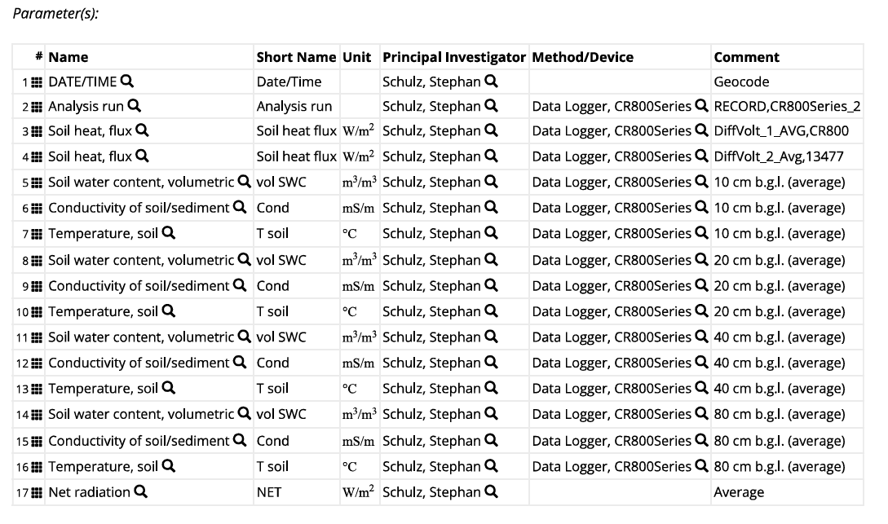

Phase 2 of the system employs the forecasting results obtained from the ensemble model, to train the Bayesian optimization model.

**4.3 DATASET DESCRIPTION**

The dataset contains soil and environmental measurements, including soil heat flux, water content, conductivity, temperature, and net radiation, collected at various depths and recorded using data loggers.

**Description of the attributes present in the dataset:**

* Date/Time:

Records the exact timestamp for each data entry, allowing for temporal analysis of soil and environmental variables.

* Analysis run:

Specifies each unique session or iteration of analysis, which may involve different processing or calibration steps.

* Soil heat flux:

Represents the rate of heat transfer per unit area in the soil (measured in W/m²), indicating energy movement within the soil, which can affect temperature and biological processes.

* Soil water content (volumetric):

Measures the volume of water in soil as a fraction of the total soil volume (m³/m³), collected at various depths (10, 20, 40 cm, etc.), providing insights into soil moisture levels and water availability for plants.

* Conductivity of soil/sediment:

Indicates ability of soil to conduct electricity (measured in mS/m), which varies based on factors like soil texture, salinity, and moisture content; a useful parameter for assessing soil health and salinity levels.

* Temperature, soil:

Records the soil temperature at different depths (in °C), offering valuable data on thermal gradients, which influence root growth, microbial activity, and soil chemical processes.

* Net radiation:

Balance between the solar radiation that is incoming and terrestrial radiation (measured in W/m²) that is outgoing; it represents the net energy available at the surface, impacting evaporation, plant growth, and soil temperature dynamics.

## 

## 

## 

## 

## 

## 4.4 EXISTING MODELS

**1. Artificial Neural Networks**

Bruno César Comini de Andrade et al. tackle inefficiencies in traditional soil heat flux models by utilizing an Artificial Neural Network (ANN) to improve prediction accuracy across diverse land covers in South America. The ANN model, trained on data from 23 flux towers, reduces the mean absolute error by up to 43%. This highlights the ANN’s capability to capture complex, non-linear relationships between the variables, underscoring the role of land cover information in enhancing predictive performance and deepening insights into soil-plant-atmosphere interactions. ***[1]***

**2.Temporal Convolutional Networks**

Yujie Liu et al. explore the potential of Temporal Convolutional Networks (TCNs) for time series prediction in their study. Acknowledging the shortcomings of traditional forecasting approaches, the authors focus on utilizing TCNs to effectively capture dependencies in the sequential data. Through this advanced deep learning architecture, the research aims to improve prediction accuracy and overcome challenges in modeling complex time series data. ***[4]***

**3.ARIMA, Prophet, LSTM, and hybrid models**

Rameshwar Garg et al. present an extensive survey of machine learning algorithms for the purposes of time series analysis and forecasting. Highlighting the importance of accurate predictions across diverse domains, the study reviews models like ARIMA, Prophet, and LSTM networks. By examining both conventional and hybrid approaches, the authors provide key insights into recent developments in time series prediction techniques. ***[5]***

## 

## 

## 

## 

## 

## 

## 

## 

## 

## 

## 

## 

## 

## 

## 

## 4.5 SYSTEM WORKFLOW

The system workflow is designed to integrate both Temporal Convolutional Networks (TCN) and Artificial Neural Networks (ANN) for forecasting. The process begins with data acquisition and preprocessing, after which the model development phase is initiated. The TCN model processes the input through convolution layers, dilation, and residual block connections before applying an activation function that can produce an output tensor. Concurrently, the ANN model processes the input through hidden layers with neurons activated by ReLU. The outputs of both models are combined using stacking, leading to the development of a meta model, which ultimately generates the final predictions for forecasting.

**4.5.1 Temporal forecasting and analysis of soil heat flux values**

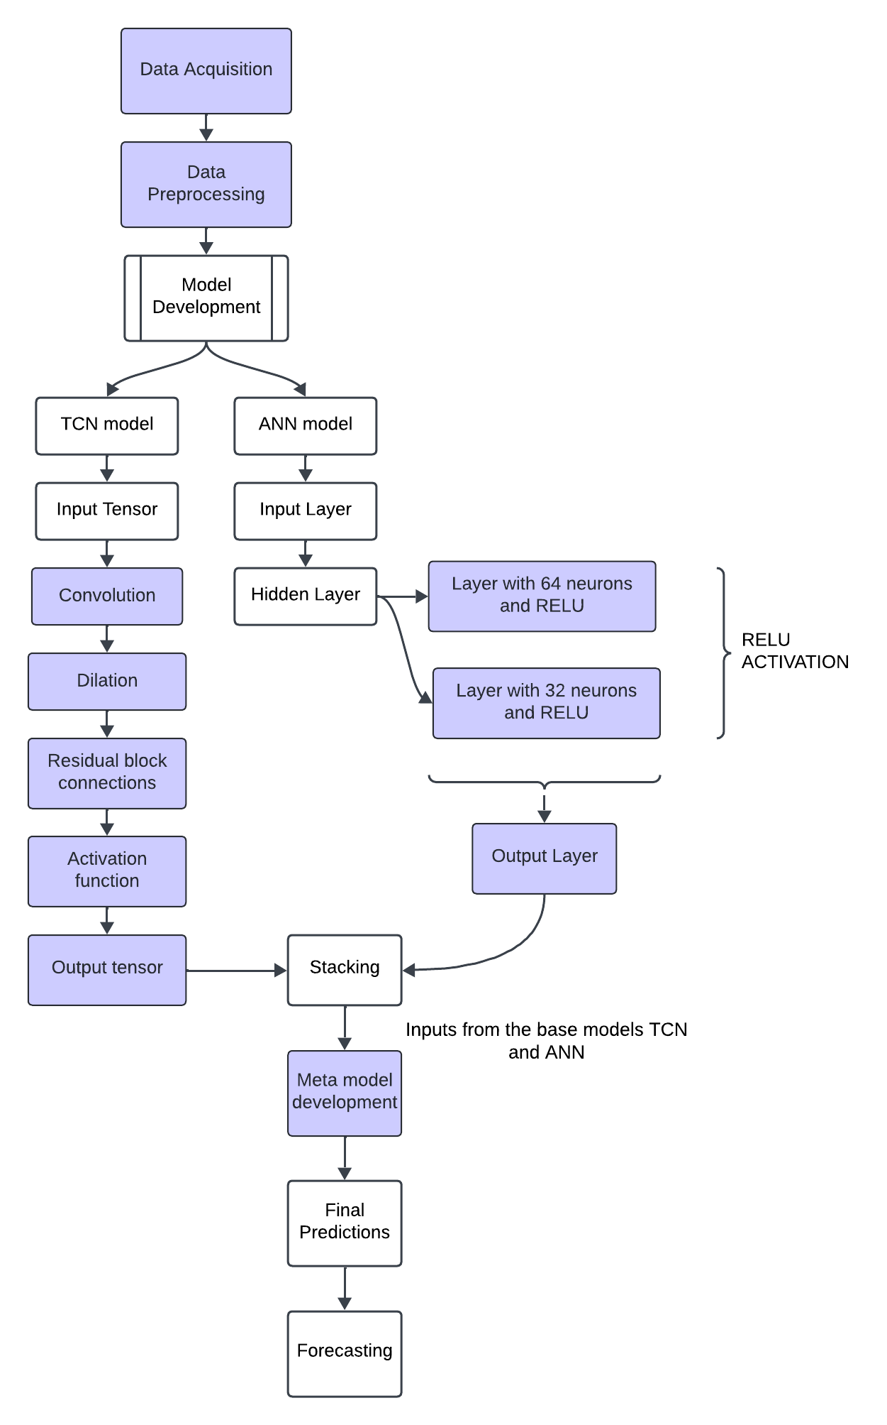

Figure 4.5.1 Flow diagram representing the workflow of the model

**Steps:**

1. **Data Collection:**

Gather soil and environmental data over time to create a dataset that captures variations in soil heat flux and related parameters.

1. **Data Preprocessing:**

Process the dataset by handling missing values, removing unnecessary columns, scaling features, and selecting relevant features to improve model accuracy.

1. **Model Development:**

Develop separate Temporal Convolutional Network (TCN) and Artificial Neural Network (ANN) models to capture different types of patterns. The TCN is designed for temporal sequences, while the ANN focuses on feature relationships.

1. **TCN Model Architecture:**

The TCN model uses dilated convolutions and residual connections, allowing it to capture dependencies in the data while maintaining efficiency.

1. **ANN Model Architecture:**

The ANN consists of an input layer and two hidden layers with 64 and 32 neurons, using the ReLU activation function (that can to add non-linearity) and model complex feature interactions.

1. **Model Stacking:**

Combine outputs from TCN and ANN models through stacking, creating a meta-model that uses the strengths of both models for improved predictive performance. It is further explained in Fig. 4.4.1.2

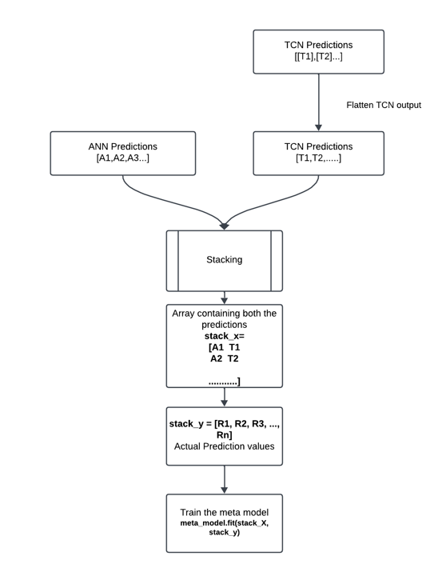

Fig.4.5.2 Flow diagram representing the stacking process to develop an ensemble model

1. **Final Forecasting:**

The meta-model generates final predictions of soil heat flux, enabling accurate forecasting for future data points based on historical patterns.

**4.5.2 Determination and optimization of plant root zone temperature**

Bayesian optimization utilizes a Gaussian Process (surrogate model), to approximate the objective function, which is deviation of the Root Zone Temperature (RZT) from an ideal target of 25°C. The workflow is demonstrated in Fig. 4.4.2.1.

The objective function measures how far the RZT deviates from 25°C, adding penalties when RZT is too high or too low, and favoring values close to this ideal temperature. The goal of Bayesian optimization is to minimize the error in RZT over multiple iterations. Instead of evaluating the objective function (computationally expensive) directly each time, Bayesian optimization relies on this surrogate model to balance exploration and exploitation of new regions and known promising areas.

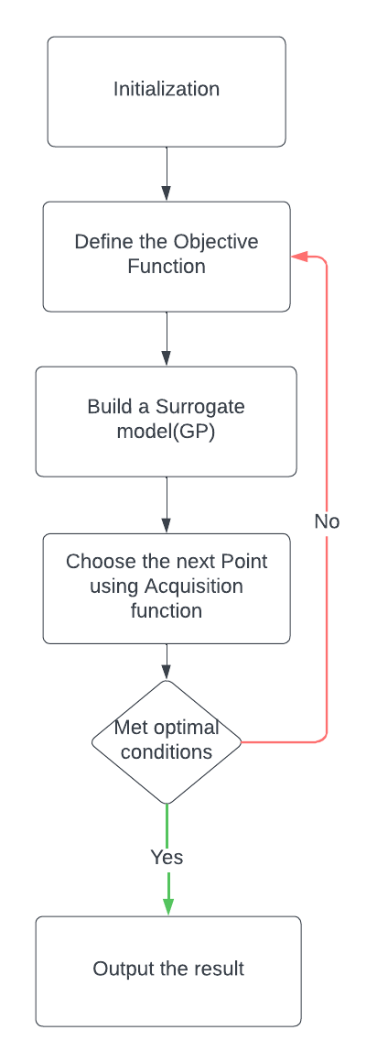

Fig. 4.5.3 Flow diagram representing the working of Bayesian Optimization

Based on data understanding, we realize that temperatures vary over different depths. Thus we employ exponential decay to determine weights associated with temperatures available at depths 10, 20, 40 and 80 cms. We also determine features that are highly correlated with temperature using the correlation heat map shown in Fig 4.4.2.2

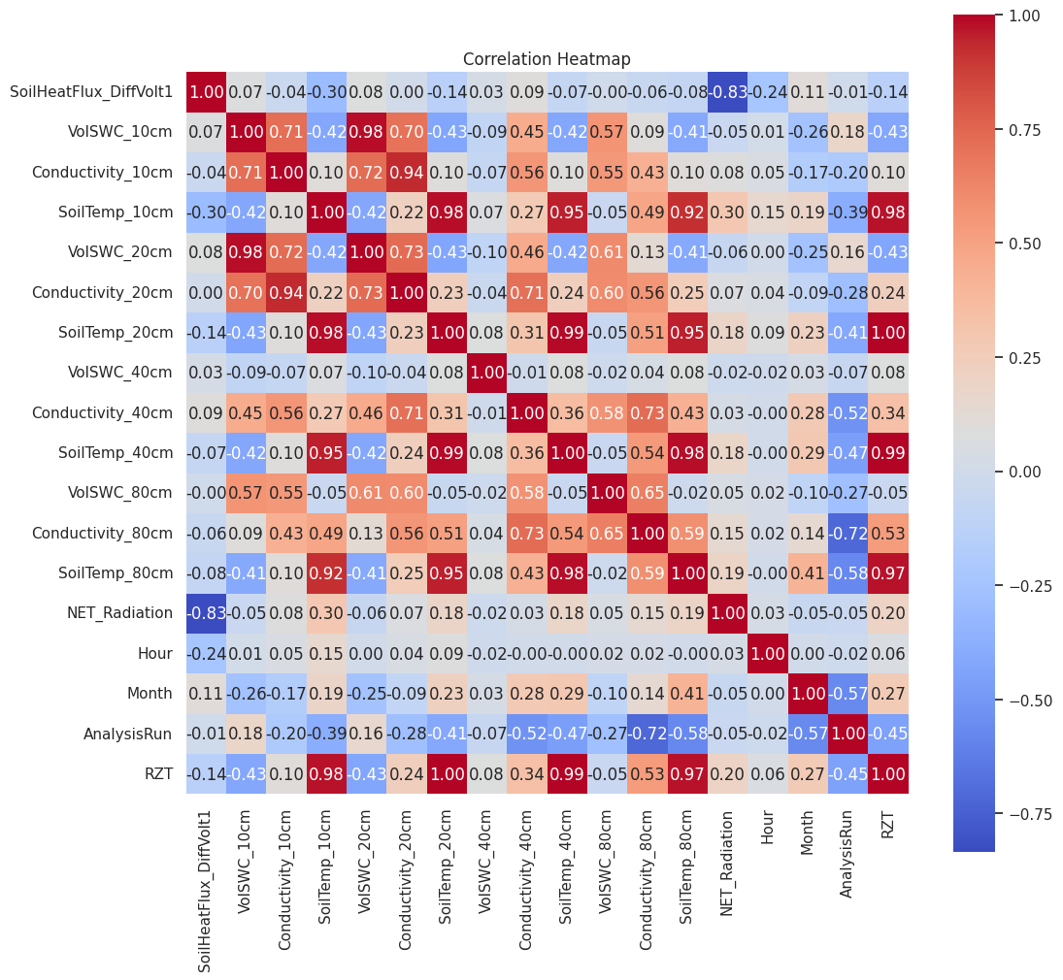

Fig. 4.5.4 Correlation heatmap illustrating the relationships between various soil parameters

## 

## 

## 

## 

## 

## 

## 

## 

## 

## 

## 

## 

## 

## 4.6 PROPOSED SOLUTION

**4.6.1 Temporal forecasting and analysis of soil heat flux values**

**1. Temporal Convolution Network:**

* TCNs use 1D convolutional layers with causal convolutions to ensure that at time step t, the output only depends on the inputs from time steps t and earlier, preserving the temporal order.
* TCNs incorporate dilated convolutions to expand the receptive field of the model exponentially, allowing it to capture long-range dependencies efficiently.
* These networks use residual connections that facilitate training of deep learning networks, preventing the vanishing gradient problem.
* TCNs can handle variable-length input sequences and are particularly effective in tasks that involve temporal sequences, such as forecasting.
* By adjusting the dilation factor and the number of layers, TCNs can be tuned to analayse both short-term and long-term patterns in data.

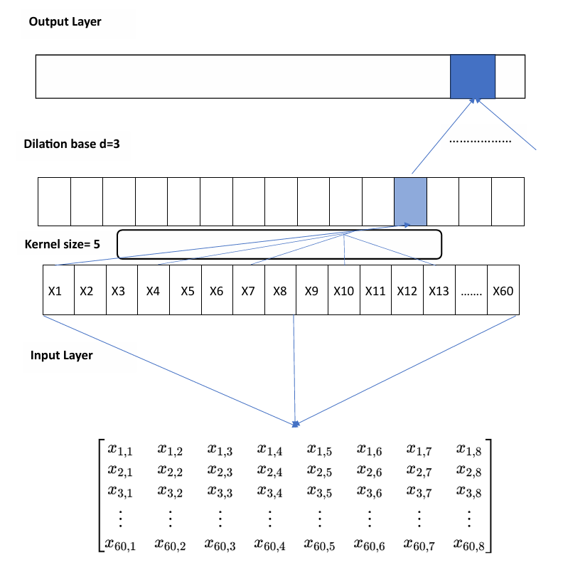

Figure 4.6.1 Architecture of Temporal Convolutional Network (TCN)

**Mathematical representation of TCN:**

* **Input Representation**: The matrix X shows input data with dimensions 60x8, representing time series data for 60 time steps and 8 features (e.g., volume, conductivity, net radiation, etc.).

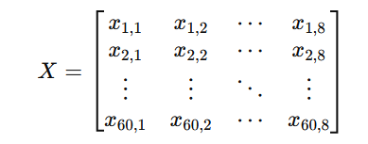 (1)

* **Convolution Operation**: The equation represents the convolution operation where y[n,j]y[n,j]y[n,j] is calculated by summing the product of a filter K over the input sequence X. The result is a feature map with 16 filters (represented by j).

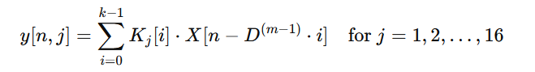 (2)

* **Dropout Application**: A dropout layer with a probability of p=0.05 is applied so that overfitting is prevented, by randomly setting a fraction of input units y′ to zero during training.

 (3)

* **Output Layer Calculation**: The output layer calculation involves flattening the dropout result and applying a linear transformation with weights W and bias b to produce the final output prediction.

 (4)

**2. Artificial Neural Network:**

* ANNs are made of layers of interconnected neurons, typically including input, hidden, and output layers, which allow for processing complex data.
* They learn by adjusting connection weights through backpropagation, minimizing the error.
* Non-linearity is introduced using activation functions (sigmoid, ReLU and tanh), enabling the network to capture complex patterns in data.

The model consists of one **input layer**, **two hidden layers** and **output layer**.

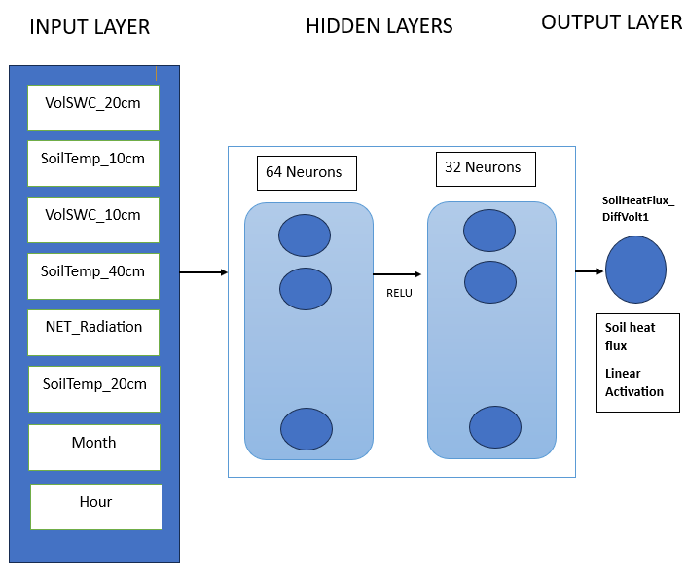

Figure 4.6.2 Architecture of ANN

**Mathematical representation of ANN:**

**Input Vector**:

 (1)  
Represents the initial input features for the neural network.

**First Hidden Layer**:

* **Weighted Sum**

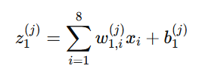: (2)

Computes sum of inputs (weighted) for each neuron in the first hidden layer.

* **Activation**:

 (3)

Applies the ReLU activation to introduce non-linearity.

**Second Hidden Layer**:

* **Weighted Sum**:

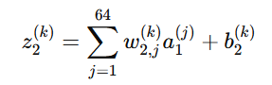 (4)

​ Calculates sum of activations (weighted ) from the first hidden layer.

* **Activation**:

 (5)

Uses ReLU to activate neurons in the second hidden layer.

**Output Layer**:

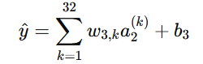 (6)

**Stacking in Ensembling**

Stacking is an ensemble learning technique that combines multiple models to improve predictive performance. In the context of the TCN-ANN stacked model, stacking involves using the outputs from both the TCN and ANN as inputs to a meta-model, which learns how to best combine these predictions for final forecasting.

Main advantage of this method is that it allows models to make use of the strengths of different algorithms. TCN captures temporal dependencies in time-series data, while ANN learns complex relationships between features. By combining their outputs, the meta-model can provide more accurate predictions than any individual model alone.

**Algorithm: Stacking Ensemble Learning with TCN and ANN**

1. Initialize Base Models

- Define base models:

BaseModels = [TCN, ANN]

2. Train Base Models

For each model in BaseModels:

a. Initialize model parameters

b. For each sample in Train:

i. Perform forward propagation to generate predictions.

ii. Calculate loss using a suitable loss function.

iii. Perform backpropagation to update model parameters

c. Store predictions on Val set:

ValPredictions[model] = model.predict(Val)

3. Prepare Stacking Dataset

a. Create an empty dataset for meta-model:

StackingData = []

b. For each sample in Val:

i. Combine predictions from TCN and ANN:

CombinedPredictions = [ValPredictions[TCN][i], ValPredictions[ANN][i]]

ii. Append combined predictions and actual target value to StackingData:

StackingData.append(CombinedPredictions + [ActualTargetValue[i]])

5. Train Meta-Model

- Initialize meta-model (e.g., Linear Regression).

- Fit meta-model using StackingData:

MetaModel.fit(StackingData)

6. Final Predictions

For each new sample in Test:

a. Generate predictions from TCN:

TCN_Prediction = TCN.predict(NewSample)

b. Generate predictions from ANN:

ANN_Prediction = ANN.predict(NewSample)

c. Combine these predictions:

CombinedInput = [TCN_Prediction, ANN_Prediction]

d. Get final prediction from meta-model:

FinalPrediction = MetaModel.predict(CombinedInput)

7. End Algorithm

**4.6.2 Determination and optimization of plant root zone temperature**

**Algorithm for Bayesian Optimization using Gaussian Processes**

**1. Initialization**

Define objective function f(x) that has to be minimized. In your case, it evaluates the penalties based on deviations of RZT from the ideal temperature.

Set initial parameters for the optimization, including:

* Bounds for the RZT values based on the dataset.
* Initial sample points (RZT values) for training the Gaussian Process (GP) model.

**2.** **Define Objective Function**

Implement the objective function that quantifies the performance based on:

* Penalties for deviations from the ideal temperature (25°C).
* Strong penalties for values below the lower bound or above the upper bound.
* Encourage RZT to reach the ideal temperature by incorporating penalties for both under and overestimations.

**3. Gaussian Process Setup**

Initialize the Gaussian Process model:

* Choose a suitable kernel function for capturing the relationships in the data.
* Fit the GP model using the initial sample points and their corresponding objective function values.

**4. Acquisition Function**

Define the acquisition function (e.g., EI) to decide where to sample next. The acquisition function helps balance exploration and exploitation.

The acquisition function should compute the expected improvement over the current best result.

**5.** **Optimization Loop**

Repeat the following steps until stopping criteria is met (maximum iterations for convergence):

* **Sample New Point**: Use acquisition function to select a new RZT value based on the GP model.
* **Evaluating Objective Function**: Compute the objective function value at the newly sampled RZT value.
* **Update GP Model**: Update the GP model with new sample point, its objective function value.
* **Update Best Solution**: Keep track of the best RZT value encountered and its corresponding objective function value.

**6. Final Output**

Once the optimization loop is complete, output the best-found RZT value that minimizes the objective function, along with its associated performance metrics.

## 

## 

## 

## 

## 

## CHAPTER 5

**IMPLEMENTATION**

## 5.1 DATA UNDERSTANDING AND PREPROCESSING

**5.1.1 Temporal forecasting and analysis of soil heat flux values**

**Data Understanding**

The dataset is numeric, containing attributes primarily of type int and float, and consists of 425,262 entries. Several observations were made regarding data quality, distribution, and trends:

* Missing Values:

There are missing values in 10 columns, with around 10 missing entries overall. These were handled during preprocessing.

* Outliers and Data Cleaning:

The SoilHeatFlux_DiffVolt1 column exhibited extreme values such as -9999, which needed to be addressed through cleaning.

SoilHeatFlux_DiffVolt2 contained all values as zero, so this column was removed due to its lack of informational value.

Figure 4.3.1


Figure 5.1.1 Box plot of Soil Heat Flux by Net Radiation Ranges

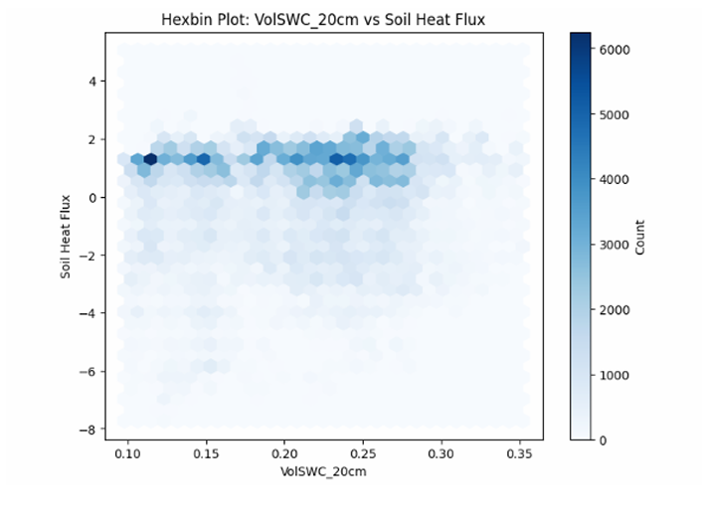

Figure 5.1.2 Hexbin plot showing the relationship between soil volume at a depth of 20 cm and soil heat flux

* Correlation Analysis:

Using a correlation heat matrix, key columns were identified that are significantly adding to the model’s predictive capabilities.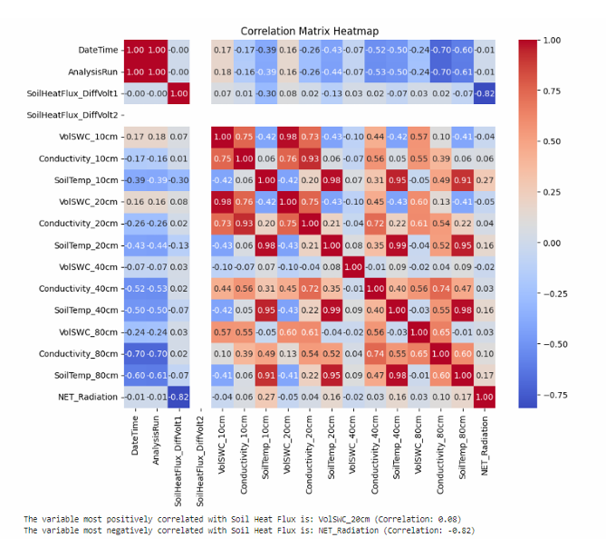

Figure 5.1.3 Correlation heatmap illustrating the relationships between various soil parameters

* Distribution Insights:

The Soil Heat Flux distribution, visualized through histograms, showed a skewed pattern, indicating the presence of outliers. Box plots and hexbin plots further confirmed the presence of outliers and highlighted correlations between variables.

* Temporal and Diurnal Variations:

Diurnal Patterns: Soil heat flux tends to be most negative during the day due to surface heating by solar radiation, indicating downward heat conduction. At night, the values shift slightly upward as heat conducts from the soil to the surface.

Overall Temporal Trends: Soil heat flux generally stays negative, with occasional sharp increases to positive values, indicating brief heat gain periods.

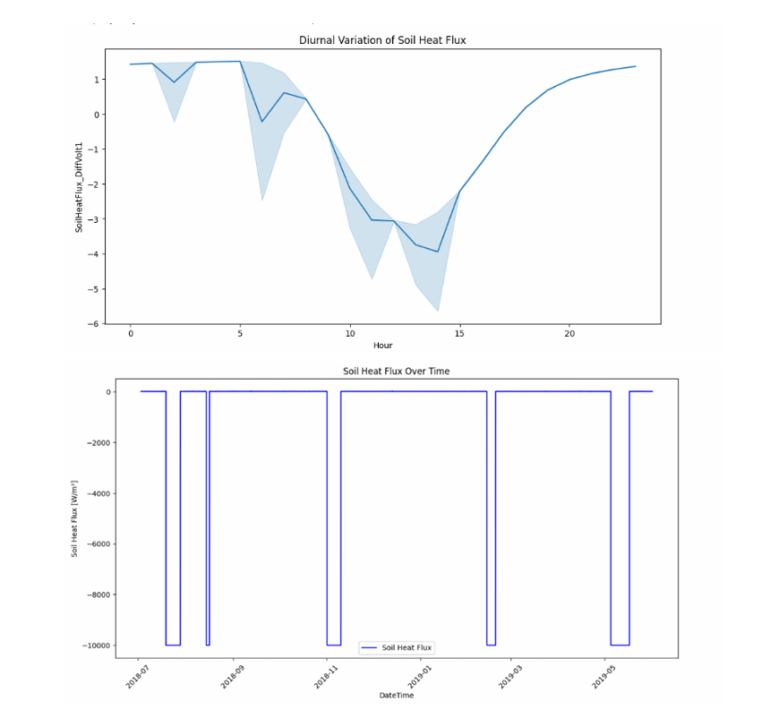

Figure 5.1.4 Diurnal variation of soil heat flux and Overall Temporal Trends

* Trend and Variability:

Rolling mean and standard deviation calculations showed periodic fluctuations in soil heat flux, with an overall downward trend indicating net heat loss.

Autocorrelation (ACF):

Analysis of the autocorrelation function (ACF) revealed flat correlations, suggesting a white noise process where values are largely random and uncorrelated.

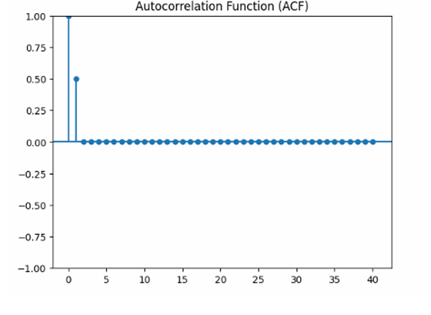

Figure 5.1.5 Autocorrelation function (ACF) plot showing correlation between the past and current values

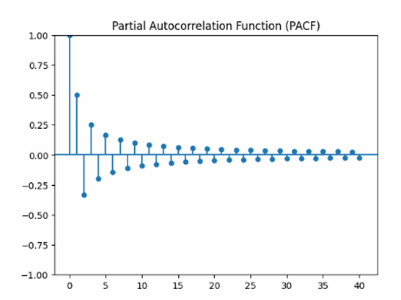

Figure 5.1.6 Partial autocorrelation function (PACF) plot illustrating correlations while accounting for the effects of intervening observations

* Annual Analysis:

Seasonal variations in soil heat flux and related parameters were observed through annual plots, providing insights into how these features vary throughout the year.

**Data Preprocessing**

Several preprocessing steps were employed to prepare the data for modeling:

* Column Dropping and Renaming:

The SoilHeatFlux_DiffVolt2 column was dropped due to constant zero values.

Columns were renamed for improved readability and understanding.

* Handling Missing Values:

Mean imputation was used to fill missing values, ensuring data consistency without introducing bias.

* Scaling:

MinMax scaler has been applied to normalize data across features, aiding model convergence.

* Outlier Removal:

Interquartile Range (IQR) filtering was made use of to detect and remove outliers, resulting in a cleaner dataset.

* Feature Selection:
* Univariate Analysis: Statistical methods such as Chi-squared and ANOVA tests were employed to identify the most significant features.
* Recursive Feature Elimination (RFE): An iterative approach was used to eliminate features with minimal impact on model performance.
* Random Forest Importance: This method assessed the significance of each feature by measuring effects on model accuracy when features were randomly getting permuted.

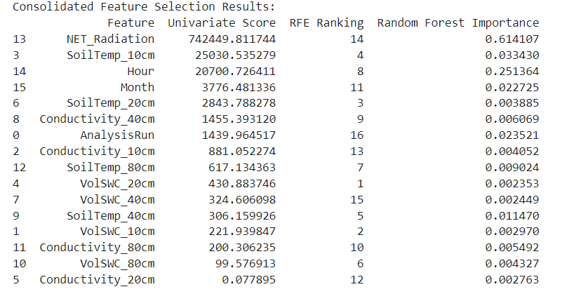

Figure 5.1.7 Results for the three Feature Selection Techniques

* Recommended Features:

Volume at 20 cm, Volume at 10 cm, Net Radiation, Conductivity, Soil Temperature at 20 cm, Soil Temperature at 10 cm, Soil Temperature at 80 cm, and DateTime.

* Resampling of time series data:

Resampling the Time Series dataset in an interval of 10 minutes to augment the number of data points in train, test and validation sets.

**5.1.2 Determination and optimization of plant root zone temperature**

**Data Understanding**

We visualize how soil temperatures vary with depth over a specified time period. It helps in analyzing temperature trends, comparing depths and understanding how soil temperature might change with seasonal variations or other environmental factors.

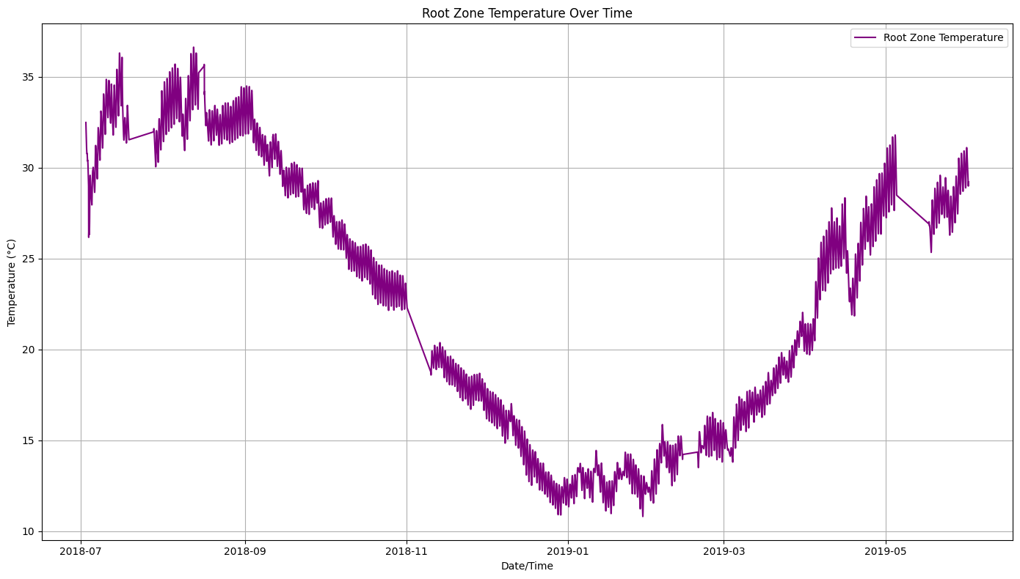

Figure 5.1.8 Plot showing the trend of Root Zone Temperature over Time (2018-2019)

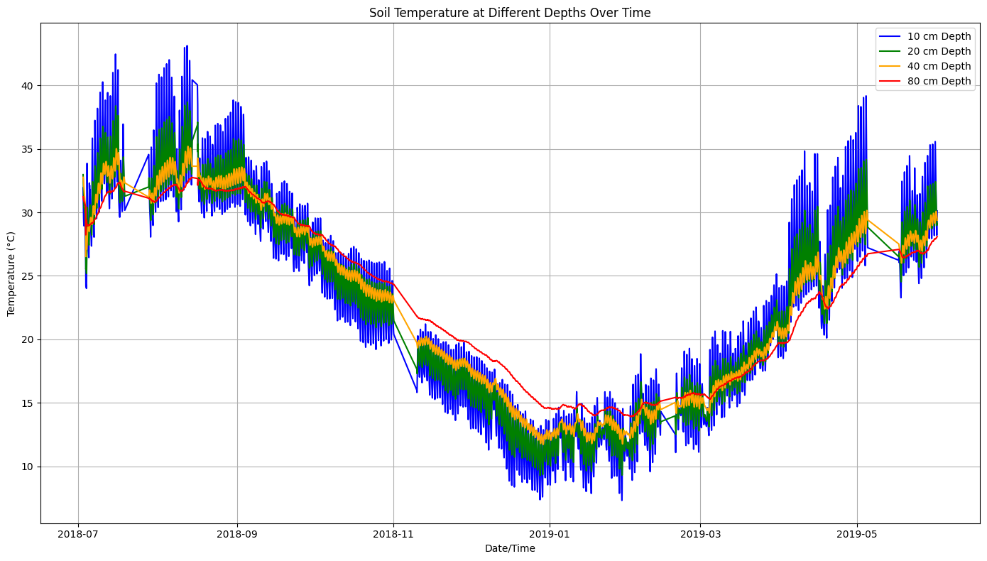

Figure 5.1.9 Plot showing the trend of Soil Temperatures at specific depths over Time (2018-2019)

**Analysis of Soil Temperature Patterns**

**1. Seasonal Variation**

Soil temperature exhibits a clear seasonal pattern across all depths, with temperatures reaching their peak during summer (mid-year) and declining in winter (end of the year). This seasonal trend reflects the influence of external climatic conditions on soil thermal dynamics.

**2. Temperature Decrease with Depth**

Observations indicate that shallower depths (10 cm) experience greater temperature fluctuations. This responsiveness is attributed to the direct influence of air temperature changes. Conversely, deeper layers (e.g., 40 cm and 80 cm) exhibit more stable temperature readings, suggesting that they are less susceptible to immediate environmental variations.

**3. Time Lag with Depth**

A notable time lag is observed in temperature changes at deeper layers (e.g., 80 cm) compared to shallower layers. This delay highlights the gradual penetration of heat through the soil profile, which affects how quickly deeper soil temperatures respond to surface changes.

**4. Moderation Effect**

Deeper soil layers (40 cm and 80 cm) display fewer temperature spikes, contributing to a more stable environment for plant roots. This stability is crucial, as it helps mitigate the impact of surface temperature fluctuations, thereby fostering better growth conditions for root systems.

**5. Overall Trends**

The analysis reveals that deeper soil layers undergo gradual seasonal changes, while shallower layers closely reflect immediate variations in air temperature. This disparity emphasizes the different roles that various soil depths play in the overall thermal environment.

**Weighted Average for Root Zone Temperature (RZT)**

The approach to calculating the Root Zone Temperature (RZT) involves assigning weights to soil temperatures at various depths to reflect their influence on plant roots:

• **Heavier Weight on Intermediate Depths (20 cm and 40 cm)**: These layers strike a balance between responsiveness to surface conditions and stability, making them critical for optimal root growth.

• **Lower Weight on Surface Depth (10 cm)**: While surface temperatures fluctuate significantly, their immediate effects diminish with depth.

• **Moderate Weight on Deep Depth (80 cm)**: This depth provides stability but is less responsive to rapid environmental changes.

**Data Preprocessing**

* **NaN Handling**: Any rows with NaN values are filtered out to avoid issues in metrics calculations and optimization. This ensures only valid data points are used in further processing.
* **Exponential Decay Weighting**: Soil temperatures at four depths (10, 20, 40, 80 cm) are assigned weights using exponential decay, assuming the influence of shallower depths on RZT is more significant. The decay rate (alpha = 0.3) controls how quickly influence decreases with depth. These weights are normalized to ensure they sum to 1, allowing a proper balance in the contribution of each depth.
* **Time-of-Day Segmentation**: Data is segmented into four intervals (Night, Morning, Afternoon, and Evening) based on the hour of the day, allowing for analysis of temperature patterns across different times.
* **RZT Calculation**: Using the weighted sum of soil temperatures, the RZT is computed for each timestamp, yielding a consolidated temperature representing the root zone.
* **Dynamic Bounds Setup**: Dynamic bounds for RZT are calculated, using the existing RZT values to establish realistic limits for the optimization process.

## 

## 

## 

## 

## 

## 

## 

## 

## 

## 

## 

## 

## 

## 

## 5.2 ALGORITHM

**Algorithm for ANN:**

1. Initialize ANN Model

- Set input size to 7 (VolSWC_20cm, SoilTemp_10cm, VolSWC_10cm, SoilTemp_40cm, NET_Radiation, SoilTemp_20cm, Month, Hour)

2. Define ANN Architecture

- Input Layer: 7 features

- Hidden Layer 1:

- Neurons: 64

- ReLU

- Hidden Layer 2:

- Neurons: 32

- ReLU

- Output Layer:

- Neurons: 1 (Soil Heat Flux)

- Activation Function: Linear

3. For each epoch in range(1, num_epochs):

a. For each training sample in the dataset:

i. Input features into the Input Layer:

X = [VolSWC_20cm, SoilTemp_10cm, VolSWC_10cm, SoilTemp_40cm, NET_Radiation, SoilTemp_20cm, Month, Hour]

ii. Forward Propagation:

Hidden_Layer1_Output = ReLU(W1 * X + b1)

Hidden_Layer2_Output = ReLU(W2 * Hidden_Layer1_Output + b2)

Output = Linear(W3 * Hidden_Layer2_Output + b3)

iii. Calculate Loss:

Loss = (Predicted_Soil_Heat_Flux - Actual_Soil_Heat_Flux)^2

b. Backward Propagation:

i. Compute gradients of loss with respect to weights and biases (W1, b1, W2, b2, W3, b3)

ii. Update weights using an optimization algorithm

4. End For

5. After training is complete, Use trained model for prediction on new input data:

Soil_Heat_Flux_Prediction = ANN_Predict([New_Features])

6. End Algorithm

**Algorithm for TCN:**

1. Initialize Parameters

- Define input matrix X of size (sequence_length, features), e.g., X ∈ R^(60×8)

- Define convolutional filters K_j for each output channel j

- Set dilation factor D(m-1) for each layer m

2. Input Representation

- Organize the input data X as a matrix with time steps as rows and features as columns.

3. For each epoch in range(1, num_epochs):

a. For each training sample in the dataset:

i. For each output channel j in the layer:

A. For each time step n:

1. Compute output y[n, j] as follows:

y[n, j] = Σ (from i=0 to k-1) K_j[i] * X[n - D(m-1) * i]

where k is the filter size.

b. Apply Dropout:

i. y' = Dropout(y, p=0.05)

c. Flatten and Output Layer Calculation:

i. Output = f(W * Flatten(y') + b)

where W is the weight matrix and b is the bias.

d. Calculate Loss:

i. Loss = (Predicted_Output - Actual_Output)^2

e. Backward Propagation:

i. Compute gradients of loss w.r.t. weights and biases (W, b)

ii. Update weights using optimization algorithm (Gradient Descent)

4. End For

5. After training is complete:

a. Use trained model for prediction on new input data:

Soil_Heat_Flux_Prediction = TCN_Predict([New_Features])

6. End Algorithm

**Algorithm: TCN-ANN Stacked Model for Forecasting**

1. Data Acquisition

- Collect and organize the dataset required for forecasting.

2. Data Preprocessing

a. Clean and preprocess the data as needed.

b. Perform scaling, normalization, or feature engineering.

c. Split dataset into train, validation and test sets.

3. Model Development

- Develop separate models: TCN model and ANN model.

4. TCN Model Development

a. Input Representation:

- Represent input data as a tensor suitable for TCN (multi-dimensional time series).

b. Convolution Operation:

- For each layer in the TCN:

i. Apply convolution operations with varying dilation factors to capture temporal dependencies.

c. Residual Block Connections:

- Implement residual blocks to ensure stable learning.

d. Activation Function:

- Apply activation functions after each convolution layer.

e. Output Tensor:

- Obtain the output tensor from the TCN model representing learned features.

5. ANN Model Development

a. Input Layer:

- Initialize the ANN model to accept specified input features.

b. Hidden Layers:

- Layer 1: 64 neurons, ReLU activation.

- Layer 2: 32 neurons, ReLU activation.

c. Output Layer:

- Apply linear activation function to predict target variable (e.g., Soil Heat Flux).

6. Stacking

a. Combine output tensors from TCN and ANN models.

b. Feed combined outputs as inputs into a meta-model.

7. Meta Model Development

a. Develop a meta-model that takes inputs from both TCN and ANN outputs.

b. Train meta-model to make final predictions based on combined learned features.

8. Final Predictions

- Use trained meta-model to generate final predictions for target variable.

9. Forecasting

a. Apply the entire stacked model pipeline to new data for future forecasting.

b. Output forecasted values as final results.

10. End Algorithm

**Algorithm - RZT Optimization using Bayesian Optimization**

**Import Required Libraries**:

Import the necessary libraries: pandas, numpy, scipy, skopt, matplotlib, and tqdm.

**Load the Dataset**:

Define the function load_data(file_path) to load the dataset:

Use pd.read_excel() to read the data.

Convert DateTime column to datetime format.

Set DateTime as index.

Call the function with the specified file path to load the data.

**Define Constants**:

Specify the depths of soil temperatures (10, 20, 40, 80 cm).

Set the decay constant alpha = 0.3 for the exponential decay weights.

**Calculate Exponential Decay Weights**:

For each depth, compute raw weights using the formula:

Normalize the weights so that their sum equals 1.

**Map Normalized Weights to Soil Temperature Columns**:

Create a dictionary weights that associates each soil temperature column with its corresponding normalized weight.

**Calculate Root Zone Temperature (RZT)**:

Define the function calculate_rzt(data, weights):

Compute the RZT as a weighted sum of soil temperatures:

Call this function to add the RZT column to the dataset.

**Segment Data by Time of Day**:

Define time intervals: Night (before 6 AM), Morning (6 AM to 12 PM), Afternoon (12 PM to 5 PM), Evening (after 5 PM)

Create a new column TimeOfDay in the dataset based on these intervals.

**Calculate Minimum and Maximum RZT Values**:

Group the dataset by TimeOfDay and calculate the minimum and maximum RZT values for each segment.

Print the minimum and maximum RZT values before optimization.

**Define Dynamic Bounds for Optimization**:

Set lower and upper bounds for RZT:

Lower bound: maximum of 10 or minimum RZT value.

Upper bound: minimum of 35 or maximum RZT value + 5.

Store the bounds in a list: bounds = [(lower_bound, upper_bound)].

**Define Objective Function**:

Implement the function comprehensive_objective(rzt):

Initialize an empty list penalties.

Extract the RZT value from the input list rzt.

For each row in the dataset:

Compare the RZT value against the ideal temperature range (18°C to 25°C) and bounds.

Append penalties to the penalties list based on the conditions specified:

Strong penalties for values below the lower bound or above the upper bound.

Moderate penalties for values outside the ideal temperature range.

Handle potential NaN values in penalties.

Return the mean of the penalties.

**Define Optimization Function**:

Implement the function optimize_row(row):

Use gp_minimize from the skopt library:

Pass the comprehensive_objective as the objective function.

Specify the bounds, number of calls (n_calls=20), acquisition function (acq_func='EI'), random state, and initial value from the current row’s RZT.

Return the optimized RZT value.

**Run Bayesian Optimization**:

Initialize an empty list optimized_rzts to store optimized RZT values.

Iterate over each row in the dataset using tqdm for a progress bar:

Call optimize_row(row) for each row to get the optimized RZT.

Append the result to optimized_rzts.

**Add Optimized Values to DataFrame**:

Create a new column Optimized_RZT in the dataset to store the optimized values.

**Display Results After Optimization**:

Print the optimized minimum and maximum RZT values for each time of day segment after optimization.

## 

## 5.3 RESULT ANALYSIS

**Performance metrics for the Ensemble model:**

### MSE (Mean Squared Error):

* **Formula**

MSE**=**  (1)

| **Epochs** | **ANN** | **TCN** | **TCN + ANN** |
| --- | --- | --- | --- |
| 100 | 0.2885 | 3.9944 | 0.2901 |
| 75 | 0.3060 | 9.1605 | 0.2866 |
| 50 | 0.4318 | 3.4131 | 0.1559 |
| 25 | 0.3305 | 3.7179 | 0.1563 |
| 10 | 0.4456 | 3.7188 | 0.2834 |

Table 5.3.1 Performance Metrics - MSE

### MAE (Mean Absolute Error):

* **Formula**

MAE **= |** (2)

| **Epochs** | **ANN** | **TCN** | **TCN+ANN** |
| --- | --- | --- | --- |
| 100 | 0.4124 | 1.4298 | 0.1713 |
| 75 | 0.4151 | 2.4254 | 0.1729 |
| 50 | 0.4226 | 1.3366 | 0.2935 |
| 25 | 0.4664 | 1.3659 | 0.2948 |
| 10 | 0.4778 | 1.3498 | 0.1468 |

Table 5.3.2 Performance Metrics - MAE

### R-squared (Coefficient of Determination):

* R squared (statistical measure)
* **Formula**

**=**  (3)

**->** Residual sum of squares

**->** Total sum of squares

| **Epochs** | **ANN (%)** | **TCN** | **TCN+ANN (%)** |
| --- | --- | --- | --- |
| 100 | 93.56 | -0.3619 | 94.16 |
| 75 | 85.26 | -3.1234 | 94.10 |
| 50 | 90.97 | -0.1637 | 94.69 |
| 25 | 92.70 | -0.2676 | 94.67 |
| 10 | 91.09 | -0.2679 | 94.99 |

Table 5.3.3 Performance Metrics - R-squared

**Results**

**Predictions for Validation set**

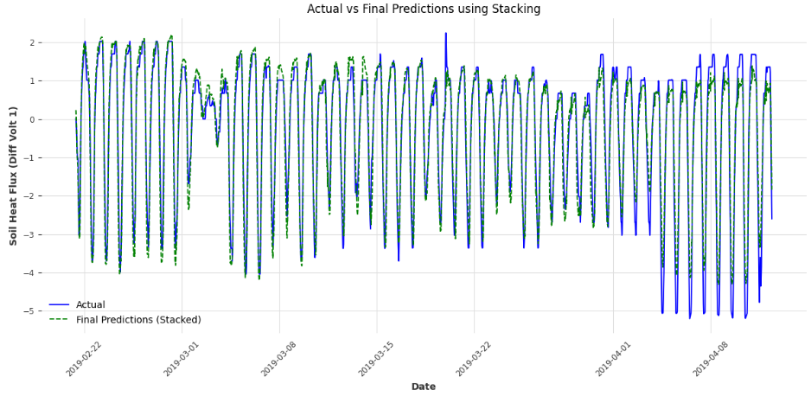

Figure 5.2.1 Plot showing the Actual vs Final Predictions of the ensemble model for the validation set

**Predictions for Testing set**

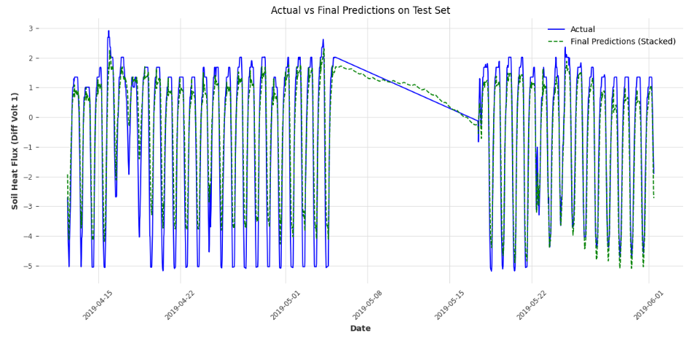

Figure 5.2.2 Plot showing the Actual vs Final Predictions of the ensemble model for the test set

**Future predictions - Forecasting**

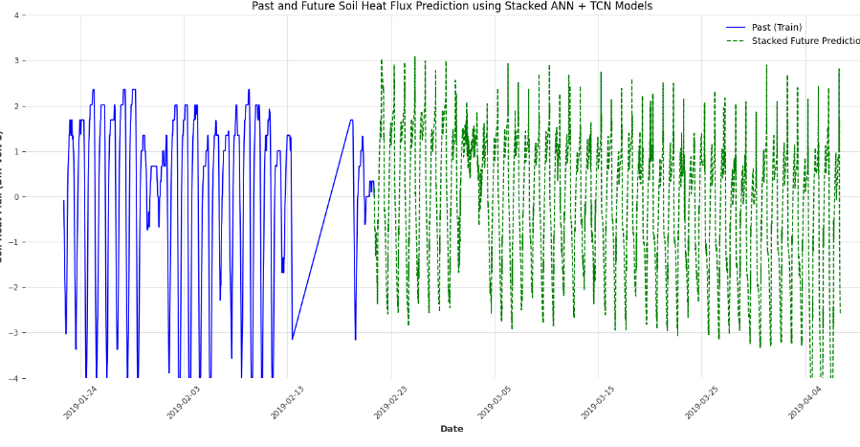

Figure 5.2.3 Plot showing the past and forecasted soil heat flux values predicted using ensemble model

**‘**

**Results for RZT Optimization Module:**

Before Optimization:

Afternoon - Min RZT: 17.25°C, Max RZT: 32.62°C

Evening - Min RZT: 17.26°C, Max RZT: 32.45°C

Morning - Min RZT: 17.24°C, Max RZT: 35.01°C

Night - Min RZT: 17.25°C, Max RZT: 33.31°C

After Optimization:

Morning - Optimized Min RZT: 18.00°C, Optimized Max RZT: 24.93°C

Afternoon - Optimized Min RZT: 18.00°C, Optimized Max RZT: 24.59°C

Evening - Optimized Min RZT: 18.01°C, Optimized Max RZT: 24.99°C

Night - Optimized Min RZT: 18.01°C, Optimized Max RZT: 24.08°C

Metrics and Results:

RMSE: 1.7582070426846619

MAE: 1.5220519743817684

MAPE: 0.07079311508752412

SMAPE: 0.07395064807160293

Max Error: 3.4999488812673683

Percentage of values within the optimal range (18-25°C): 100.00%

Highest Accuracy is **99.44%** and is achieved at threshold **±3.450°C**

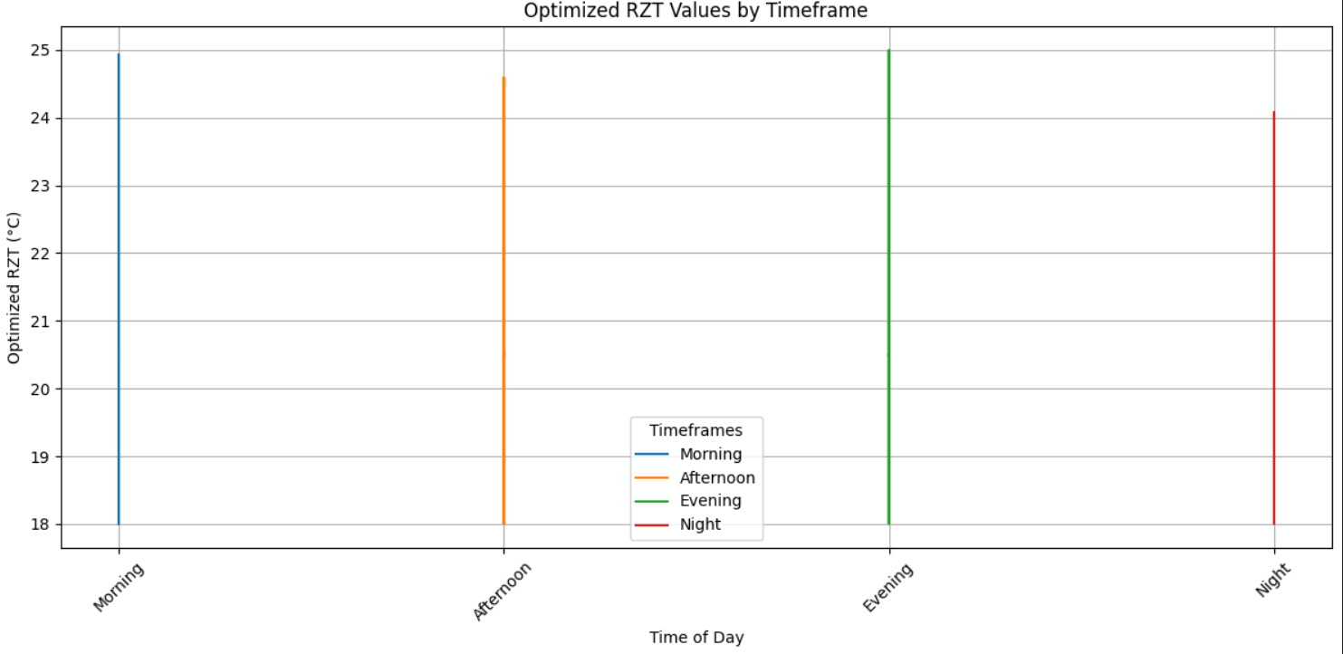

Figure 5.2.4 Plot showing the optimized values of the temperatures in four timeframes

**CHAPTER 6**

**CONCLUSION**

In conclusion, the project successfully developed an ensemble model for forecasting soil heat flux dynamics, which is crucial for optimizing plant root zone temperature and enhancing agricultural productivity. The primary models considered were TCNs and ANNs. While the TCN model effectively captured long-range temporal patterns through dilated convolutions, its performance varied across different epochs. The ANN model, which excelled in capturing non-linear feature interactions, achieved an accuracy of 93.56%, demonstrating its capability to process data but not fully addressing the temporal aspects as effectively as the TCN.

To further improve predictive performance, an ensemble model combining TCN and ANN was developed, leveraging the temporal strengths of TCN alongside the general feature-learning capacity of ANN. This ensemble model achieved an accuracy of 94.69%, showing notable improvements in prediction accuracy when in comparison to individual models. Evaluation metrics such as MSE, MAE, and R-squared values revealed that the ensemble approach provided more accurate predictions for soil heat flux dynamics.

Additionally, Bayesian optimization was introduced to refine the optimization of plant root zone temperature. The initial RZT was determined using an exponential decay method, providing a robust starting point for the optimization process. By integrating Bayesian optimization with the ensemble model, we could effectively explore and exploit the parameter space, leading to enhanced accuracy in predicting soil temperature variations.

Ultimately, while both TCN and ANN models contributed valuable insights, the TCN+ANN ensemble model combined with Bayesian optimization emerged as the best-performing solution for predicting soil heat flux. This approach not only offered superior accuracy and reliability in forecasting soil temperature variations but also demonstrated significant potential for advancing agricultural practices through optimized management of soil resources.

## 